**Gantt Chart:**

Gantt chart is a visual project management tool which displays the schedule of a project. In this project we used a Gantt chart to manage the schedule of our project. The details of Project like task Name, Duration, Start date and Finish Date are clearly mentioned in the Gantt chart.

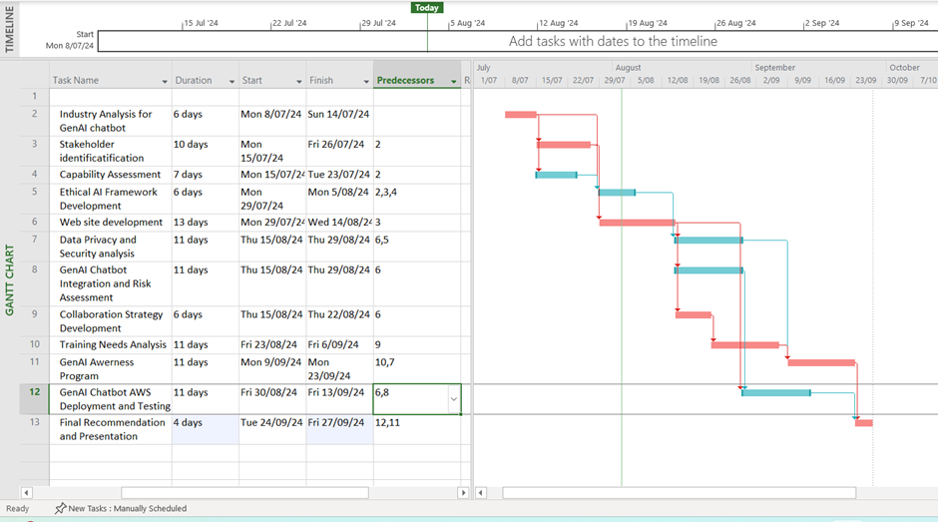

**Project Network Diagram:** We used a project network diagram tool to visualize the sequence of project activities and the dependencies among them. It clearly shows the order of the tasks and how they interrelate. It also helps to identify which tasks can be done simultaneously. Finally, It also indicates the earliest and latest start and finish times for each task. To ensure clarity and readability, the overall network diagram in Figure 1 has been partitioned into three distinct sections so that we can see detailed information.

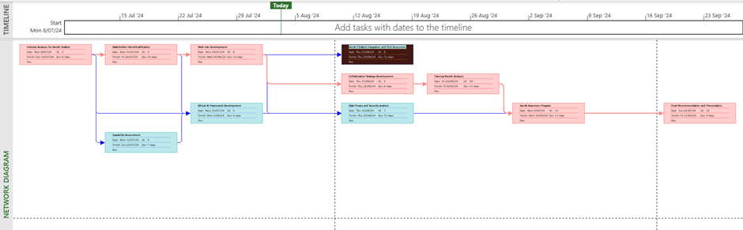

Figure 1: Overall Network Diagram

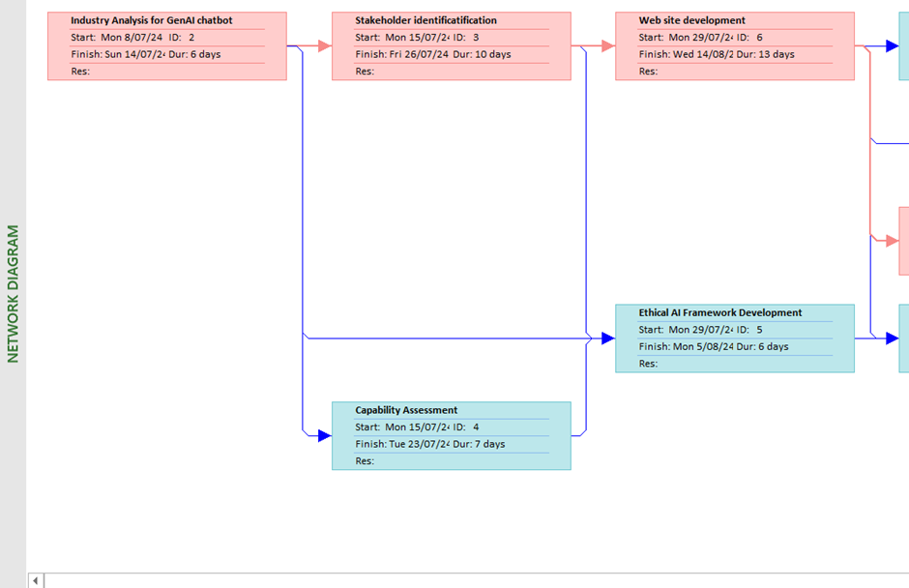

Figure 1.1: Network diagram Part-1

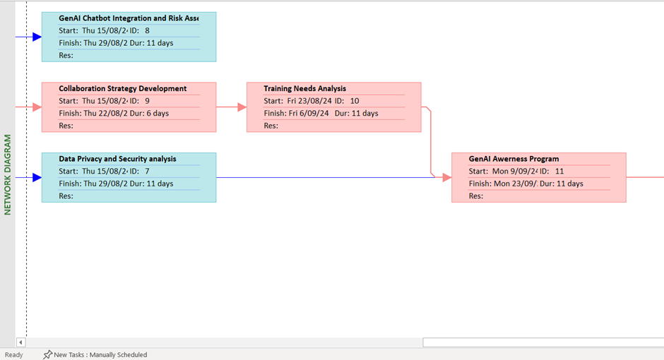

Figure 1.2: Network diagram Part-2

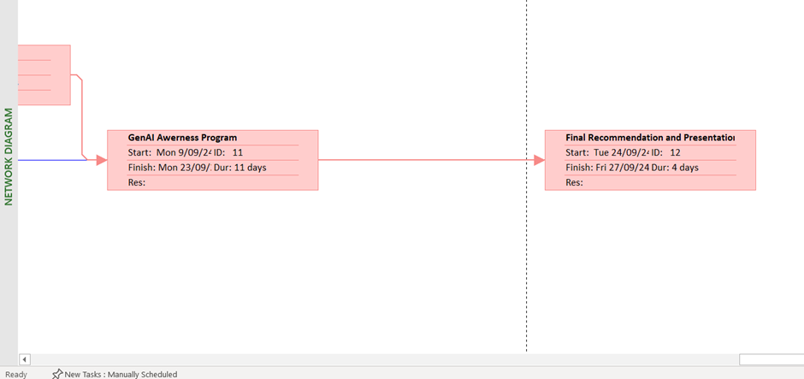

Figure 1.3: Network diagram Part-3